WORLD AMATEUR CHESS CHAMPIONSHIPS
2 - 12 April 2020
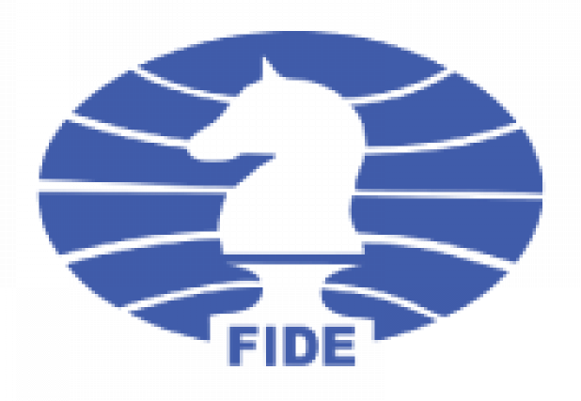

Registration & Booking Form

Forward to the Organising Committee:
FIDE World Amateur Chess Championships 2020
***** Aldemar Knossos Royal – Crete – Greece *****
(Attn: for Mr Nikos Kalesis)
Tel: +30 6938326161
Email: registrations@crete2020.org

Instructions: 1. Registration forms must be sent by e-mail to the Organising Committee by 17 February 2020.
2. A deposit payment of 30% for the registration-accommodation package costs must be paid in advance to the bank account specified below (net of bank charges), also by 17 February 2020.
3. Passport numbers are necessary only for players or accompanying persons who need visa permission to enter Greece.
4. Flights refer to the Heraklion International Airport (IATA code: HER) for 2 April (arrivals) and 12 April (departures). Please mention your exact times of arrival & departure.

NATIONAL FEDERATION:
Contact person: | Tel.:
Email: | Fax:

Payment in bank (in euros): | Number of persons:
A deposit payment of 30% for the registration-accommodation package costs is necessary to the following bank account to confirm participations (bank charges on the sender’s side):

Bank: Bank of Cyprus Account Holder: AT HOLIDAYS SMPC Account Holder’s Address: Apollonos 4, Athens 10557 - Greece Bank Address: Esperidon 12, Nicosia 1087 - Cyprus Account Number IBAN: CY74002001950000357022795355 BIC/SWIFT Code: BCYPCY2N

After payment, please send a copy of the bank receipt by email: registrations@crete2020.org

List of Players |  |  | Arrival | Depart
Category | Full name & passport number | FIDE ID & Rating
Open/Men u-2300
Women u-2300
Open/Men u-2000
Women u-2000
Open/Men u-1700
Women u-1700
 | Total of players:

List of additional coaches, accompanying persons, etc. |  |  | Arrival | Depart
Position | Full name & passport number | FIDE ID & Rating
Coaches
Accomp. persons
 | Total of acc. persons:

Please make your delegation's room list (total number and type of rooms)
Total Number of triple rooms (3x):
Total Number of double rooms (2x):
Total Number of single rooms ( 1x):
OFFICIAL HOTEL: 5-star ALDEMAR KNOSSOS ROYAL (*****)

Registration – Accommodation package includes (per person):

- Accommodation for 10 nights.
- Breakfast, lunch and dinner, including potable water (full board) daily.
- Transportation from and to Heraklion airport on 2nd and 12th April.
- Registration and FIDE fees.
- All taxes (including VAT and Municipality Tax).

Price in triple room Price in double room Price in single room
670 euros per person 710 euros per person 950 euros per person

* Extra nights can be requested in advance and, upon availability, can be possible at
a proportional cost as per the official prices on the event invitation.

Room No. 1 (names):

Room No. 2 (names):

Room No. 3 (names):

Room No. 4 (names):

Room No. 5 (names):

Room No. 6 (names):

PS: Use other paper or expand the document for more space if your delegation is larger.

Date:
Name & signature of responding official:

